Step 1:
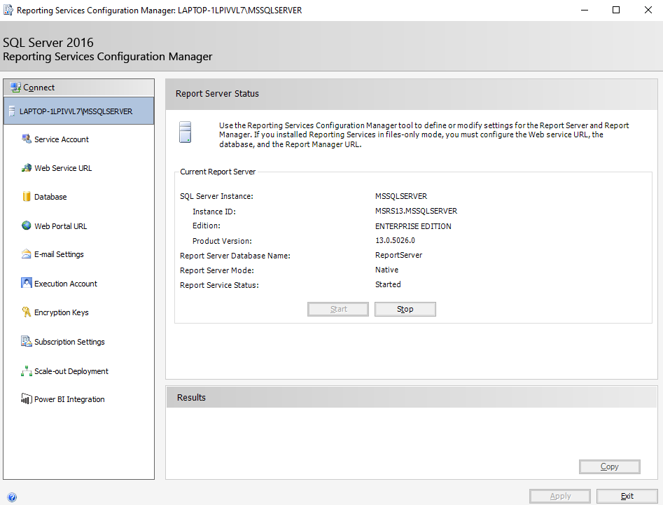

Step 2:
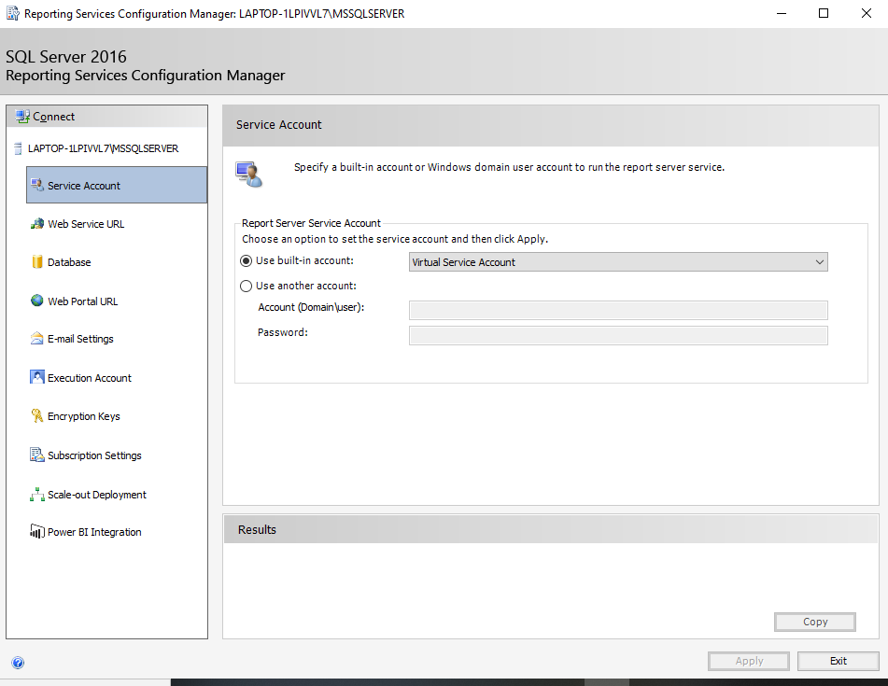

Step 3:
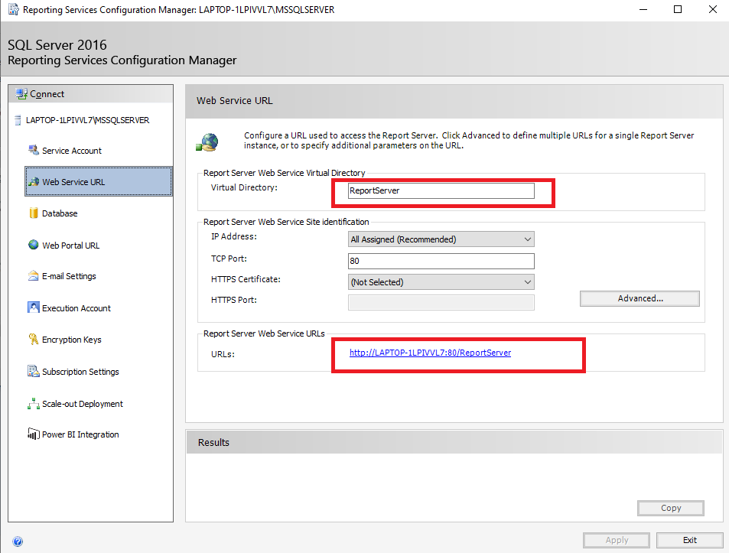

Step 4 :

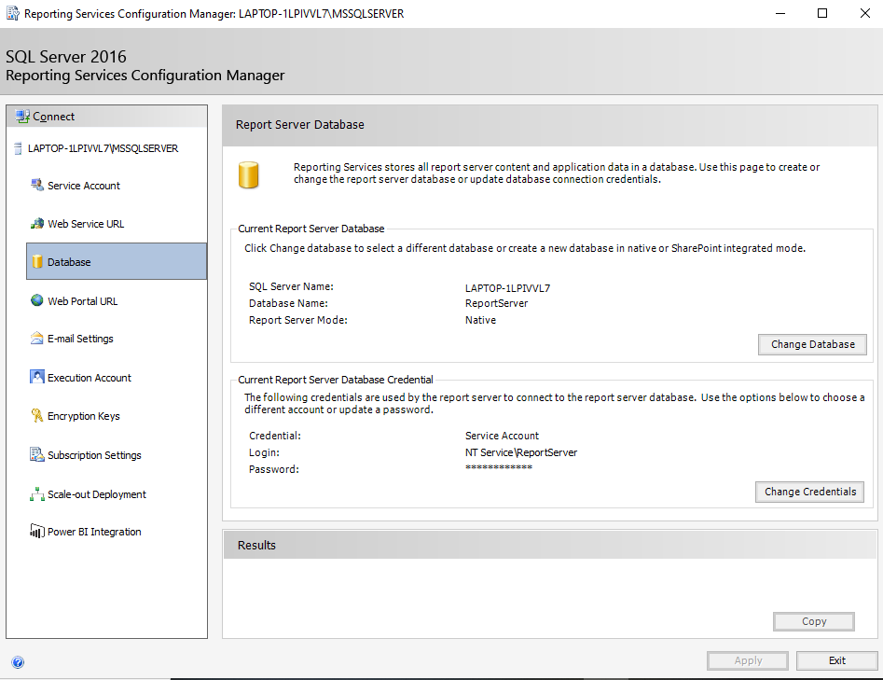

Step 5:

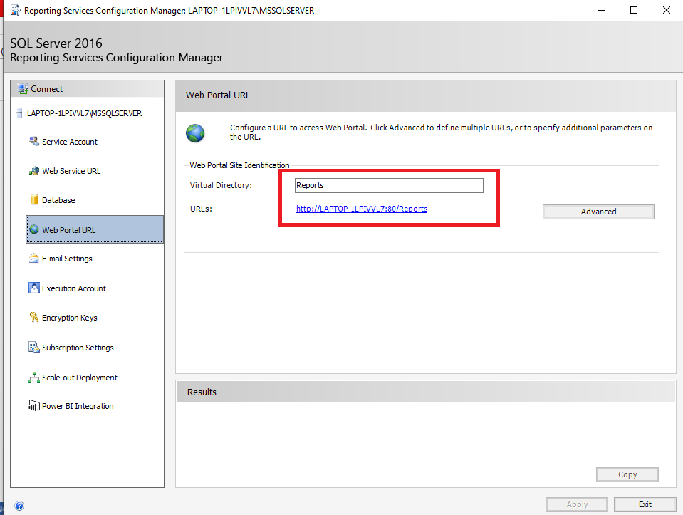

After setup We need two URL :
Step 3 Web Service URL :
This URL need to be access from different network. In my local it’s showing as below.
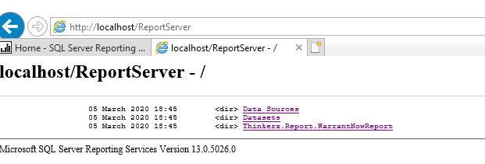

Step 5 Web Portal URL :
This URL need to access from different network and use to deploy reports into reporting server.
In my local its showing as below.

